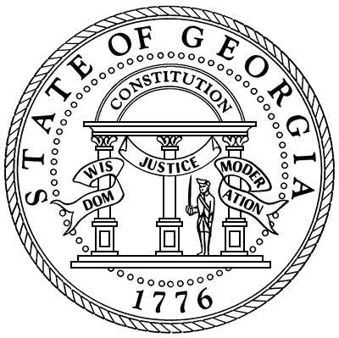

# Oglethorpe County Superior Court

**Honorable Kelli Paradise Smith**

**Superior and Juvenile Court Clerk**

**Post Office Box 68**

**Lexington, Georgia 30648**

**(706)743-5731**

**Fax(706)743-5335**

**Email: kelli.smith@gsccca.org**

**By order of Senior Superior Court Judge Samuel Ozburn, all jurors who were summoned for July 21, at 9:30 a.m. will NO LONGER need to report. Thank you, Kelli Paradise Smith, Clerk of Superior Court. 706-743-5731, kelli.smith@gsccca.org.**