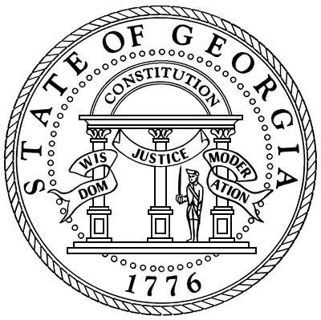

# Oglethorpe County Superior Court

**Honorable Kelli Paradise Smith**

**Superior and Juvenile Court Clerk**

**Post Office Box 68**

**Lexington, Georgia 30648**

**(706)743-5731**

**Fax(706)743-5335**

**Email: kelli.smith@gsccca.org**

**By order of Superior Court Judge Jeffery S. Malcom, all jurors who were summoned for March 18, 2023, at 1:30 p.m. will need to report for service. Thank you, Kelli Paradise Smith, Clerk of Superior Court. 706-743-5731, kelli.smith@gsccca.org.**