# IN THE SUPERIOR COURT OF OGLETHORPE COUNTY NORTHERN JUDICIAL CIRCUIT

**STATE OF GEORGIA**

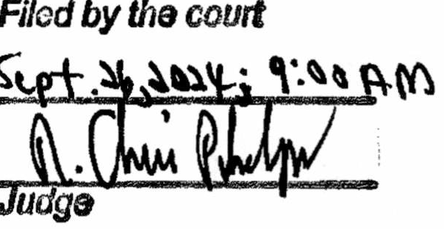**TO THE JUDGES AND CLERK OF SUPERIOR COURT TO THE JUDGE(S) AND CLERK OF STATE COURT**

**TO THE JUDGE(S) AND CLERK OF MAGISTRATE COURT TO THE JUDGE(S) AND CLERI( OF PROBATE COURT**

**TO THE JUDGE(S) AND CLERK OF MUNICIPAL COURT TO THE JUDGE(S) AND CLERK OF JUVENILE COURT**

**ORDER**

**DECLARATION OF JUDICIAL EMERGENCY**

**WHEREAS,** it has been determined that a judicial emergency exists in this county and that a state of emergency has declared by the Governor; and

**WHEREAS,** the emergency substantially endangers or infringes upon the normal fonctioning of the judicial system, the ability of persons to avail themselves of the judicial system, or the ability oflitigants or others to have access to the courts or meet scheduled or time deadlines imposed by the court order or rnle, statute of administrative rule or regulation;

**IT IS ORDERED** that, pursuant to O.C.G.A. § 38-3-61, the Courts of Oglethorpe County shall be closed on F1iday, September 27, 2024 **to expire at 5:00 p.m. on September 27, 2024;** and

**IT IS FURTHER ORDERED** that, pmsuant to O.C.G.A. § 38-3-62, all court deadlines, time schedules or filing requirements are hereby suspended, tolled, or extended for the duration of the judicial emergency as noted above; and

**IT IS FURTHER ORDERED** that the Sheriff or his/her designee shall post a copy of this notice on the courthouse doors ; and

**IT IS FURTHER ORDERED** that the Clerk of the Superior Comi, or his/her designee, shall immediately notify the Chief Justice of the Supreme Court and the Clerks of the Court of Appeals and Supreme Court by sending them a copy of this notice; and

**IT IS FURTHER ORDERED** that, the County Manager, or his/her designee, shall post a copy of this notice and any subsequent modification or extension in accordance with O.C.G.A § 38-3-63 by posting it on the county website or other appropriate public address system.

th

**SO ORDERED** this26 dayo f September, 202.4 .' -

R. l·is Phelps

Chief Judge, Oglethorpe Superior Comt Northern Judicial Circuit