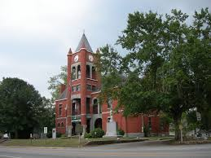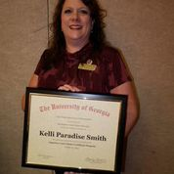

KELLI PARADISE SMITH, CLERK OF SUPERIOR COURT, OGLETHORPE COUNTY
I would like to thank the citizens of Oglethorpe County for their continued support and trust allowing me to serve unopposed for my third term as your Clerk of Superior Court in our great county! I will continue all the good work preserving the wonderful history and acting as the custodian of our very important records we have in the county dating back to 1794. I would also like to take this opportunity to thank my wonderful staff, which none of my success would be possible without them. Cheryl Joines, my Chief Deputy Clerk, Alisa Williams, my Civil Deputy Clerk, and Robbie Buchanan, my Real Estate Deputy Clerk. They are family to me and are such an integral part of why and how we have come so far so fast. Again, thank you! I am honored and humbled. I can do all things through Christ who strengthens me.

